

**Doc #: QP 8.4-1 Rev. C**

**Approval Date: 4/6/2021**

**Approved By: Bryon Nolan**

**Supplier Quality Management**

**Production Part Approval Process (PPAP) Manual**

**Amerequip Corporation**

**1015 Calumet Avenue**

**Kiel, WI 53042**

**Table of Contents**

**Contents**

Table of Contents 2

Foreword 3

Production Part Approval Process (PPAP) 3

Purpose 3

When is PPAP Submission Required? 4

New parts, process or suppliers: 4

Changes to existing product: 4

Determination of Requirements Related to the Product 4

Casting Specific Process Requirements 5

Casting PPAP Submission: 5

Supplier Change Request (SCR) Instructions 6

Elements of a PPAP Submission 7

Submission Levels 7

Electronic Submission/Submission Method 8

Submission Status 8

Ongoing Requirements 9

Instructions for completing a PPAP Submission 9

**Element 1 Part Submission Warrant (PSW) 10**

**Element 2 Design Records & Ballooned Drawings** 11

**Element 3** **Dimensional Results** 12

**Sample Requirements** 12

**Completing the Initial Sample Inspection Report (ISIR)** 12

**Element 4 Material, Coating and Performance Test Results 13**

**Element 5 Control Plan 14**

**Element 6 Approved Engineering Change Documentation 16**

**Element 9 Process FMEA (PFMEA) 18**

**Element 10 Measurement System Analysis Studies (MSA) 20**

**Element 11 Initial Process Study (Cpk, Ppk) 20**

Element 12 Appearance Approval Report 22

Element 13 Sample Parts 22

Element 14 Amerequip Specific Requirements 23

Element 14a Customer Paint Certification Form 23

Element 14b Packaging Form 23

Element 14c BOM Audit 24

**Appendix A – Definitions 24**

Appendix B – Critical to Quality Characteristics (CTQ) 31

**Designated Key Characteristics** 31

Appendix C – Revision History 32

**Foreword**

The Quality Assurance staff at Amerequip Corporation has prepared this handbook for new and existing suppliers of manufacturing based purchased goods to Amerequip. Its purpose is to define the approval process of new or revised parts, or parts resulting from new or significantly revised production methods. As a supplier, it is your responsibility to ensure that you ship only parts that have been approved and meet specifications.

The procedures outlined in this handbook apply to all Amerequip facilities. If you have questions regarding the contents or processes described in this manual, please contact Amerequip Supplier Quality. Amerequip Corporation has specific customer specific requirements that need to be fully understood before attempting to successfully submit a PPAP to Amerequip for review and approval.

## Production Part Approval Process (PPAP)

## Purpose

The purpose of the Production Part Approval Process (PPAP) is:

* To provide the evidence that all customer engineering design record and specification requirements are properly understood and fulfilled by the manufacturing organization.
* To demonstrate that the now established manufacturing process has the potential to produce product that consistently meets all requirements during an actual production run at the quoted production rate.

## When is PPAP Submission Required?

In general, a PPAP is required anytime a new part or a change to an existing part or process is being planned. It is at the discretion of Amerequip Corporation to determine when and if a PPAP submission will be required. As a supplier you should have the type of quality system that develops all of the requirements of a PPAP submission regardless of whether you have been asked to deliver a submission. In the event a PPAP submission is not requested, Amerequip quality reserves the right to request any of these documents at any time during the life of the product. Amerequip Quality reserves the right to request a PPAP submission for a variety of reasons including all of the following.

## New parts, process or suppliers:

1. New part or product

2. New supplier

3. New process or technology

## Changes to existing product:

1. Change to construction, material, or component

2. New, additional or modified tools

3. Upgrade or re-arrangement of existing tools

4. Tooling, production, or equipment transferred to a different site

5. Change of supplier or non-equivalent materials/services

6. Product when tooling has been inactive for 12 months

7. Product or process changes on the components of the product

8. Change in test or inspection method

9. Bulk material: New source of raw material

10. Change in product appearance attributes

11. Change in production process or method

12. Change of sub-supplier or material source

If there are any questions concerning the need for a PPAP Submission, please contact an Amerequip Corporation Quality or Supplier Quality representative.

## Determination of Requirements Related to the Product

Specific quality planning activities are required as determined by Amerequip Supplier Quality. Quality Planning activities help ensure that new products or processes, and changes to existing products or processes, fulfill the intended purposes. Quality Planning provides a consistent, structured, and preventive process for managing risks associated with new or revised parts and assemblies, and with changes to suppliers and processes.

One of the activities that can be required is the Design, Process, and Assembly Review (DPAR).

A DPAR is a meeting which confirms all expectations of the products or services prior to a physical build. Amerequip teams initiate this review as early as possible before tooling release. Documentation of DPAR events shall be maintained by Amerequip.

Production Part Approval Process (PPAP) requirements shall be clearly understood as an output of the DPAR.

Unless otherwise communicated, the supplier shall document conformance to all specifications, dimensions, and drawing notes on the Initial Sample Inspection Report (ISIR).

A graphical representation (ballooned drawing) shall accompany the ISIR.

The PPAP requirements shall be documented on a Verification Warrant Form.

The required Production Part Approval activities are determined by Amerequip Quality.

After the PPAP documents have been submitted, Amerequip Quality reviews the data and either approves or rejects the verification warrant. Approval is required prior to shipping production parts for all physical builds. Conditional approval may be granted to authorize limited production shipments when there are outstanding PPAP requirements.

## Casting Specific Process Requirements

These requirements are in addition to any requirements identified in Amerequip Engineering Specifications and or on the Amerequip Approved Product Drawing and included as a part of an Amerequip Purchase Order and Contract:

1. The supplier shall utilize destructive (sectioning & trial machining) and or non-destructive test capability (such as: x-rayed/ultrasound) for the validation of all casting internal integrity during the product development stage. If the supplier does not have in-house capability, they shall contract an ISO/IEC 17025 (or national equivalent) certified external source, which shall need Amerequip SQE approval.
2. The supplier shall conduct on the 1st Production Run:
   1. A minimum of 1 piece (3 samples total) from the beginning, middle and end of the production run must be sectioned, analyzed, and documented to validate process stability & consistency with the development runs and within specification limits.

## Casting PPAP Submission:

1. The PPAP submission must be based on data taken from the initial production run and must include.
2. Destructive test photos of the sectioning and or trial machining results conducted in the development runs & initial production run.

And/or

1. Non-destructive test documentation (x-rayed/ultrasound reports & or film) from the part evaluated in the initial production run.
2. No production parts from the initial production run shall be shipped to Amerequip prior to the supplier receiving a signed PSW indicating PPAP approval has been issued.

## Supplier Change Request (SCR) Instructions

Whenever you are planning a change that affects the part or the process making the part you must get approval from Amerequip prior to initiating any activity.

This document, Supplier Change Request (SCR), is used for initiating all supplier changes.

The SCR must be approved by both Amerequip Purchasing and Quality.

Failure to have an approved SCR may affect future business opportunities.

The SCR identifies several “Types” of changes that require notification. All of these changes can have significant effect on overall part quality and are therefore identified for customer approval prior to making the change to avoid any unforeseen issues at Amerequip facilities or with end user customers. **As a supplier to Amerequip Corporation you are not under any of these circumstances allowed to make a change without prior notification and approval of the SCR form.**

Below are the types of changes that require prior notification and approval by Amerequip Corporation.

1. Use of other construction or material than was used in the previously approved part.
2. Production Following Refurbishment Modification of tool to increase the performance) or rearrangement (Modification of tool which changes the sequence of product / process flow) of existing tooling or equipment.
3. Production from tooling and equipment transferred to a different plant location or from an additional plant location.
4. Change of subcontractor for parts, non-equivalent materials, or services that affects customer fit, form, function, durability, or performance requirements.
5. Product produced after the tooling has been inactive for production for twelve months or more.
6. Product and process changes related to components of the production manufactured internally or manufactured by subcontractor that impact fit, form function, performance.
7. Change in test / inspection method - new technique. Evidence to be provided that the new method provides results equivalent to the old method.
8. For materials:
   1. New source of raw materials with specific characteristics from new or existing, change in production appearance attributes where there are no appearance specifications, revised parameters in the same process, change outside of design FMEA of the approved product.

## Elements of a PPAP Submission

One or more of the following elements may be required as part of your formal submission depending upon your assigned submission level:

1. Part Submission Warrant (Amerequip Specific Format Required)

2. Design Records & Ballooned Drawings

3. Dimensional Results (Amerequip Specific Format Required)

4. Material Test Results, Coating, Heat Treat Test Results

5. Control Plan

6. Approved Engineering Change Documents

7. DFMEA

8. Process Flow Diagram

9. PMFEA

10. Measurement Systems Analysis (MSA)

11. Initial Process Study (Cpk) Capability Studies

12. Appearance Approval Report (AAR)

13. Sample Product Parts

14. *Amerequip-Specific Requirements*

A. Customer Paint Certification Form

B. Packaging Form

C. BOM Audit

## Submission Levels

Submission levels define which elements are required to be submitted. The levels are used for different reasons and applications. The level to be submitted is determined by Amerequip Corporation, and unless otherwise noted, always defaults to Level 3 which is a full PPAP submission. There are five submission levels listed below, and each is ***typically*** applied to the specific areas listed.

**Level 1**  **Certificate of Compliance (COC)** **only as requested.**

Applied to: Catalog/ commodity parts and re-certification of existing parts previously approved by Amerequip at levels 3, 4 or 5. Also used for self-certification.

**Level 2** **Warrant and limited supporting data submitted to the customer**.

Applied to: Critical Bulk products such as Paint/Chemicals, simple material changes, simple revision level only changes or simple print updates not affecting form-fit-function. This level can also be applied to low and medium risk parts within a product family.

**Level 3** **Warrant with product samples and complete supporting data submitted to customer.** **Default Amerequip Corporation Submission Level.**

Applied to: New parts on Amerequip programs, changes affecting form-fit-function, reliability, or performance. All products sourced to new suppliers, serial production parts, and existing parts undergoing a part number change/revision.

**Level 4** **Warrant and other requirements as defined by the customer**. This level is reserved for special applications only. Applied to: This level can only be applied with prior approval from the designated Amerequip Quality representative.

**Level 5 Warrant with product samples and complete supporting data reviewed at the supplier’s manufacturing location.** Applied to: On site review as requested by Amerequip.

**Note:** Parts sourced in other countries that are delivered to North America must be translated into English and must be Level 3 submissions. Changes to existing parts will be handled on a case-by-case basis and submissions other than level 3 must have prior approval from your Supplier Quality representative.

## Electronic Submission/Submission Method

Amerequip Corporation requires that all PPAPs be submitted electronically. The preferred method of submission is via:

* Email to [PPAP@amerequip.com](mailto:PPAP@amerequip.com)
* Alternately email to your quality/supplier quality representative.

It is preferred that the PPAP be 1 PDF file of the entire submission. If this is not possible then we would request that each element would be in PDF format and not Native format such as MS Excel or Word. Important: The use of a paper submission must have prior approval by the authorized Supplier Quality or Quality representative. All submissions must be received prior to the PPAP due date.

## Submission Status

The review and approval process will be managed by Amerequip. PPAP submission will be reviewed and dispositioned with one of the following submission statuses:

**Approved:** A formal acceptance of the submission within the guidelines of any and all criteria set forth by the Amerequip division managing the submission.

**Rejected:** The provision is not acceptable and needs to be resubmitted for approval. *(****Note:*** *Submission to the wrong revision level or part number will constitute an automatic rejection.)*

**Conditional**: A conditional approval can occur through an agreement with quality management. The product must be deemed “sellable” by Amerequip and the interim may only be issued for 90 days. The submission must have an approved Specification Deviation that clearly identifies the corrective action plan to achieve full approval within the 90 day period. The Specification Deviation is in the Amerequip Corporation’ PPAP Forms Workbook.

## Ongoing Requirements

Amerequip Corporation reserves the right to request any information you have provided in any data or documented in any element of approval, at any time, including after the approval has been granted. Amerequip Corporation reserves the right to require recertification at any time.

As a supplier to Amerequip Corporation, the expectation is that you will build your product and processes to be robust not only for the launch of the product but for the life of the product. The expectation is that your system will include verification of the parts and the part requirements on an “on-going basis”. This includes building periodic conformance testing into your overall process such as routine dimensional analysis, functional analysis and process verification.

## Instructions for completing a PPAP Submission

**All submissions must be received prior to the PPAP due date.**

## Element 1 Part Submission Warrant (PSW)

The purpose of the ***Part Submission Warrant* (PSW)** is to document the submission and the approval or rejection of purchased parts prior to production. Amerequip Corporation has developed its own Part Submission Warrant document and this form is a required element of PPAP. It must be submitted as part of the PPAP at every submission level. Amerequip Corporation will not accept the AIAG form or any internal PSW format.

**Completing the Part Submission Warrant** The Part Submission Warrant is included in the forms file in the Amerequip Corporation’s PPAP Workbook. It must be filled out and signed by the supplier. The part number must match the Purchase Order or material agreement that is provided by Amerequip Purchasing.

The form must be submitted in this format, with the correct part number and revision level. This is 1 of 2 forms that are mandatory for all Amerequip submissions. Any fields that do not apply to your submission should be filled in with “N/A” (Not Applicable).

It is critical to make sure the PSW is filled out correctly, and contains accurate and legible information. A sample of the Part Submission Warrant described above can be found below. **Each field in the Amerequip PSW in the workbook has comments that provide additional clarity on each field**.

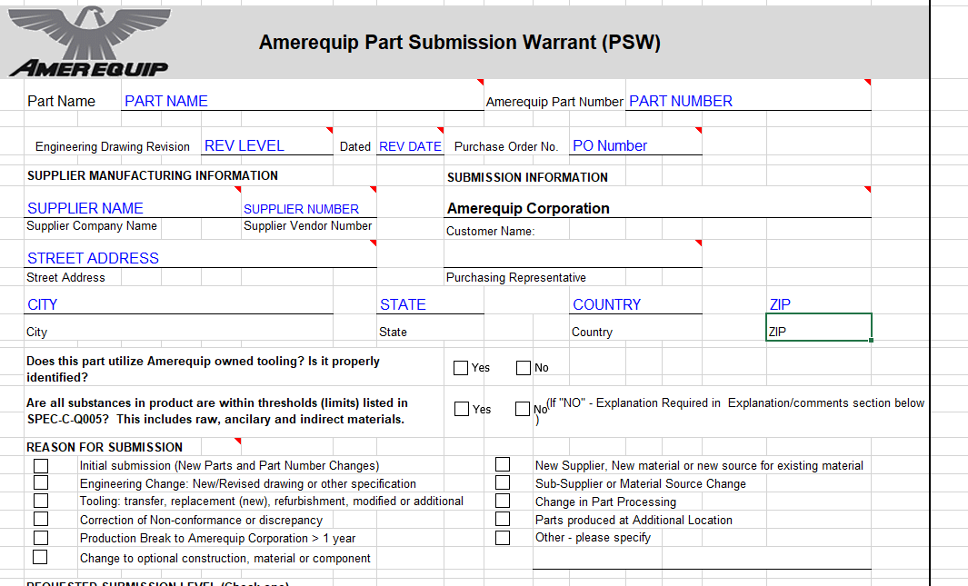

**Element 2 Design Records & Ballooned Drawings**

The purpose of **design records and ballooned drawings** is to document and provide a

copy of the formal part print and to provide any additional engineering records for

reference.

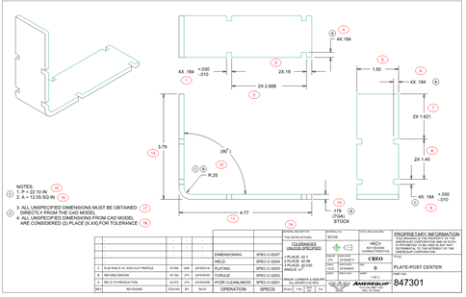

***Example of a Balloon Drawing***

A **ballooned drawing** shows the parts or assemblies in a part print with numbered “balloons”

that point to individual dimensions and requirements of the part. The numbers on the

ballooned drawing must correlate with the numbers found on the Initial Sample Inspection Report (ISIR). **A ballooned drawing must be submitted as part of PPAP for every submission** **level when there are dimensional results.**

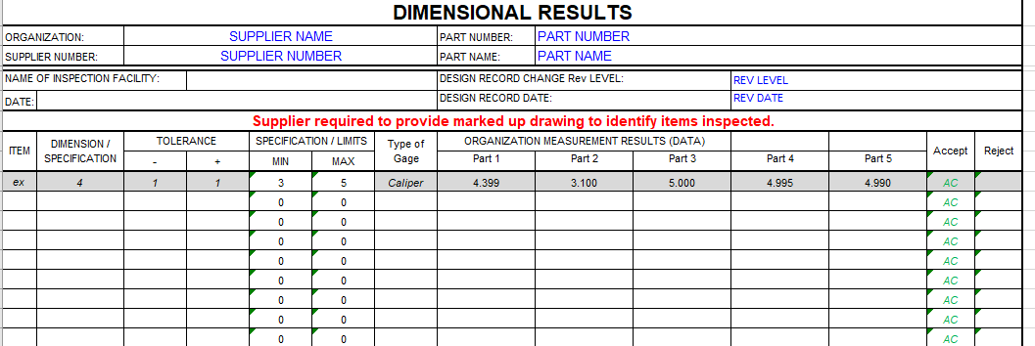

**Completing the balloon drawing**

All part requirements on the Amerequip print must be ballooned and numbered for reference

and measurement. These may include:

1. Dimensions and tolerances of parts

2. Weld requirements (weld length, size, weld notes, no weld zones.)

3. Visual features (color, texture, etc.)

4. Chemical characteristics (cure time, etc.)

5. Physical and mechanical properties (tensile strength, plating thickness, heat-treat hardness, etc.)

6. Any other specified requirement that is described in print notes or referenced specifications.

When dimensions are specified at multiple locations on the drawing, the data for each location

should be numbered separately.

Material or Performance data should be included in Element 4 on a format that allows for

clear interpretation of the results. For example, material results can be addressed using a

material composition report or a certificate of analysis. Either an in-house format or the AIAG

formats for material and performance are acceptable.

**Element 3** **Dimensional Results**

The **Dimensional Results** are documented in the **“Initial Sample Inspection Report**

**(ISIR)”** provided in the workbook. The measurements on this form should correlate

with your balloon drawing from Element 2.

The purpose is to show conformance to the Amerequip Corporation part print on

dimensions and all other print requirements. Non-dimensional requirements should be

addressed in the Material and Performance section of the PPAP submission.

**Amerequip requires a full dimensional layout of the part on all PPAP submissions**

**except level 1 for all drawings related to the part.**

The parts used for dimensional data must be from production tooling. The dimensional

report must address all of the following:

* All dimensions.
* All applicable notes that have variable dimensions (example: tensile test)
* Any dimensions contained on reference prints.
* Tolerances that include bonus points for Geometric Dimensioning & Tolerancing (GDT) callouts.

**Sample Requirements**

**Important: The parts measured for Element 3 should be the same parts submitted as formal samples.**The minimum number of parts to measure for the dimensional element is 5 parts. These

must be the same 5 parts that are submitted as **Sample Parts**. All parts

should be identified with the corresponding number on the part or the tag.

**Completing the Initial Sample Inspection Report (ISIR)**

All dimensional requirements on the ballooned drawing must be listed on the Dimensional

Data Sheet. The Dimensional element **must be submitted** on the Amerequip Corporation

ISIR. If multiple pages are required to complete a full inspection, all copies of the ISIR

must include completed headers. When requirements are referenced at multiple locations

on the print the data must be recorded for each individual location. All callouts and notes must be included.

All sections of the ISIR must be filled out completely. The **Method of Measurement** must

be documented for every line item set of data. In addition, on GD&T tolerances the

specification and any bonus tolerance must be added to the minimum and maximum

tolerances.

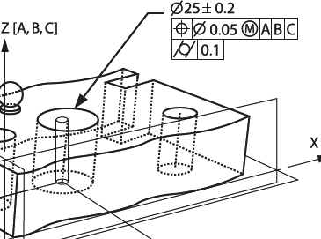

***Example:*** This call out would require 5 lines of separate data on the dimensional report.

1. Hole diameter (25 ± 0.2)
2. *X* Basic Dimension
3. *Y* Basic Dimension
4. True Hole Position (0.05 MMC on Datum A,B,C)
5. Cylindricity (0.1)

The following condition will result in this requirement being deemed unacceptable:

* 1. Any requirement that is non-conforming

This condition will require corrective action to be addressed and identified on the ISIR. The proposed corrective action should address the cause and what will be done in response.

Any concerns identified in the ISIR should be brought to the attention of Amerequip Purchasing or Quality before submitting your PPAP documentation. **We expect all suppliers to place the formal dispositions on each line item.**

**Element 4 Material, Coating and Performance Test Results**

**Material/Performance Test Results** is a broad category for the majority of all other test results other than the dimensional results reported in the previous element. Either your own in house documents or AIAG forms may be used for test results. Amerequip Industries is primarily concerned that the **material is confirmed** and the **acceptable performance is demonstrated**. If there is a performance requirement make sure the results of the testing are acceptable, credible and performed to the specification. Together with the ISIR, this section of the submission should address a *complete* review of all product specifications and/or part print requirements.

**Material Test Results** should be provided in the form of a material composition report typically called a **Certificate of Analysis (COA)** from an accredited lab that confirms the material content meets a known standard. It is your responsibility as a supplier to Amerequip to confirm the composition of your material for both the PPAP submission and ongoing conformance. It is also your responsibility to plan for ongoing material conformance testing and identify this as a separate requirement (line item) in your control plan. This ensures that you have a plan for continuing conformance to the material standard.

Amerequip’s expectation is that you have a designated lab (internally or externally) that is capable of confirming your raw material on a periodic basis. The interval of inspection is recommended by the supplier however Amerequip reserves the right to request a change in the frequency of inspection any time throughout the life of the part to ensure the quality.

**Certificate of Compliance (COC)** is acceptable but not preferred. Amerequip Corporation prefers to have results in the format of Certificate of Analysis (COA). The COA will show

actual test results to a known standard rather than simply certifying that a material meets the standard.

Performance Test Results should be acceptable, credible and meet the agreed upon specifications to be measured. Performance results may include data confirming any referenced specifications in the part print or specific testing required by Amerequip Corporation. Amerequip Corporation, engineering or quality will communicate specific material, performance, and testing requirements either the in part print, reference specifications or by specific request prior to PPAP approval. It is the responsibility of the supplier to confirm the data and format for this requirement with their Amerequip Supplier Quality representative.

## Element 5 Control Plan

A Control Plan defines the operations, processes, materials, equipment, methodologies, and

CTQs (as determined by Amerequip, contract customers and suppliers) for controlling

variations in key product or process characteristics integral to the manufacturing process. Its

purpose is to communicate the supplier’s decisions during the entire manufacturing process

from materials purchase through final shipping. Specifically, the control plan should address the following:

* Methods of production
* Identification of CTQ characteristics’ controls
* Secondary or outsourced operations
* Materials and their physical and chemical characteristics
* Types of process equipment at each operation
* Types of test equipment used to measure each characteristic
* Specifications, sampling strategy, control and reaction methods used
* Periodic conformance testing and product verification

All processes must have a control plan that defines all methods used for process control and complies with the customer-specified requirements. The control plan must clearly state each step in the process; the specification & all Critical to Quality (CTQs) must be addressed for product and process.

**Completing the Control Plan**

Completing the Control Plan is a fairly straightforward process whereby the supplier simply documents all materials and processes involved in the manufacturing process from start to finish. The process flow diagram and ballooned drawing provide inputs to the Control Plan. All CTQs identified as Process, First-Piece, or Safety Related by the supplier must be listed on the control plan form. Additionally, the supplier will list decisions that are foreseen to affect the outcome of production.

**Control Plan Template included in the PPAP Workbook**

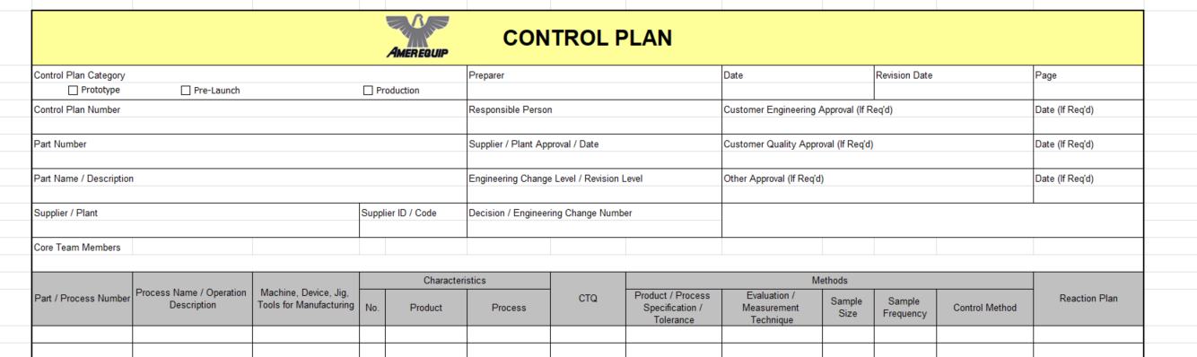

A control plan should address all testing requirements, inspection and measurement that are required to make a quality product. Suppliers should also include other details they know to be vital in the process. The control plan cannot be excessively dependent on visual inspection and should target prevention techniques wherever possible. The control plan can be submitted on the Amerequip Corporation supplied format or any internal compliant format.

The control plan should be developed in stages from proto-type through production. Early planning on the control plan will usually result in a more robust process. Suppliers should develop a pre-launch control plan early in the development of a new product and submit it to their Amerequip Corporation representative for feedback. This will allow both the supplier and Amerequip to troubleshoot and finalize the production level control plan early and avoid unexpected costs or delays. Amerequip may also request that you provide specific documents required at PPAP early in the development phase and the most common one is a pre-launch Control Plan.

It is vital the control plan describes the actions required within the manufacturing process flow to ensure that all process outputs are in a state of control and that every step in the process requiring disposition has a defined “Control Method” and “Reaction Plan” outlined on the control plan. This includes all forms of testing, inspection, measurement and process setup. The “Reaction Plan” should clearly define any contingency planning that may need to be addressed during the manufacturing of the product.

Finally, the Control Plan should be a living active part of your overall quality system. Amerequip Corporation prefers that all suppliers develop the Control Plan methodology as part of their everyday practice and Quality system. Control plans should not be developed just for a PPAP submission and in the event of an issue will typically be requested by Amerequip.

**Element 6 Approved Engineering Change Documentation**

This section is used to cover anything that is not addressed in a part print such as emails, **Supplier Change Requests (SCR),** and Feasibility Studies.

* **Amerequip ECNs** must be approved, not pending.
* Print change submissions must have current prints.
* Emails can only clarify requirements, not define them
* Emails cannot re-define a requirement in lieu of a print change.
* All supplier-initiated changes must have a copy of an approved Supplier Change Request (SCR) form.



The Supplier Change Request must be approved by both Amerequip Purchasing and Quality prior to making any proposed changes. You should not proceed with your change until you have an approved SCR from Amerequip.

**Element 7 DFMEA**

**Design FMEA** stands for **Design Failure Mode and Effects Analysis (DFMEA)** and shows evidence that potential failure modes and their associated risks have been addressed in order to eliminate or minimize their effects through product design changes and improvements. DFMEA is only required when the part is designed by the supplier and must address all Critical to Quality characteristics (CTQs) and any potential voice of the customer inputs identified in the Amerequip Project Scope.

The date on the DFMEA should show release prior to print release. Severity, Occurrence and Detection ratings are used when performing FMEA activities. Amerequip has included a worksheet format in the forms Workbook.

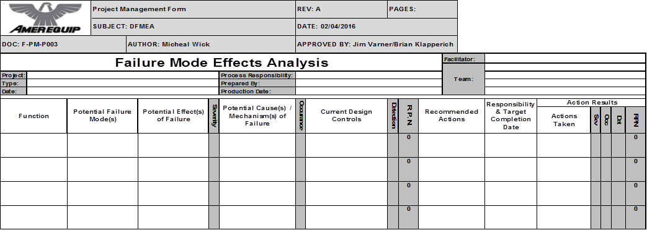

Above is the form and an example of how the ratings scale for Severity for easy reference.

Any potential failure mode not mitigated in the DFMEA should be included in the PFMEA also included on the PPAP worksheet.

Any potential failure mode with a severity ranking of 9 or 10 must be addressed with

a corrective action plan. Furthermore, potential failure items in the top 25 percent high **RPN** ranking should have corrective action items addressing the potential failure mode.

Organizations that have already developed a DFMEA or PFMEA can submit that as part of their PPAP submission. For organizations without a DFMEA or PFMEA, sample forms have been included in the PPAP Workbook. The chart below describes the fields in the DFMEA.

**Completing the DFMEA**

The DFMEA supports the design process by reducing the risk of failures. The DFMEA should be initiated before the design concept is finalized. Each item/function needs to be addressed. Any potential failure mode of the item/function should be defined as completely as possible. Recommended actions should be recorded. All severities of 9 or 10 must have an associated action plan. Prevention is the preferred method to address the design failure mode. If prevention is not possible, then highlight detection controls. The DFMEA is not meant to be a stand-alone document and the results of the DFMEA can be used in the PFMEA.

The FMEA tables for Severity, Occurrence and Detection are a separate tab within in the workbook on Amerequip’s FMEA template. The three of these ratings multiplied together produce the initial **Risk Priority Number or RPN.**

Severity x Occurrence x Detection = **RPN**

**The use of an RPN Threshold is not recommended practice for determining the need for actions.** Applying thresholds assumes that RPNs are a measure of relative risk (which they often are not) and that continuous improvement is not required (which it is). Amerequip Corporation recommends that you treat all FMEA activity on a separate case-by-case basis and that you address the top 25% of your highest RPN values within the FMEA activity you are doing.

**Element 8** **Process Flow Diagrams**

The purpose of Process Flow Diagrams is to document and clarify all the steps required in the manufacturing of a part. The Primary process steps must match the Control plan. Process flows must include the entire manufacturing process (receiving through shipping).

**Scrap Inspection Testing**

**Non-conforming product flow**

**Rework**

**Shipping**

**Finished Goods Warehousing**

**Raw Goods Warehouse**

**Raw Goods Receiving**

Manufacturing Process

The Process Flow Diagram must also include all key steps in the process and all offline activities (such as measurement, inspection and handling). The flow of nonconforming material such as scrap parts, non-conforming parts and rework parts should also be included. The Process Flow can be provided in any format used within an organization.

## Element 9 Process FMEA (PFMEA)

The **Process FMEA (PFMEA- Process Failure Mode and Effects Analysis)** is used to show evidence that any potential failure modes and risks have been assessed at the manufacturing process level. Process FMEA’s can be submitted in the Amerequip format or any AIAG compliant format. Amerequip Corporation has provided a PFMEA Worksheet in excel format in the PPAP Forms Workbook. Like the DFMEA, it also contains that latest rating definitions for FMEA Revision 4.

A PFMEA should be performed for every part, piece of equipment or process involved in manufacturing. PFMEA is a cross-functional activity that is performed internally, updated routinely and reviewed periodically. Severity, occurrence and detection ranking values are included in this handbook, as well as in the PPAP Workbook.

Amerequip Corporation requires that any severity ranking of 9 or 10 be addressed with a corrective action plan. Furthermore, potential failure items in the **top 25 percent** of the high RPN ranking items **must have** action items addressing the potential failure mode. This in turn will lower the re-calculated RPN value for that failure mode. Any high RPN process concerns should be carried over and addressed in the **control plan**. All critical failure modes must be addressed.

**Completing the PFMEA**

The PFMEA worksheet is a tool used to identify and show potential process risks associated with the manufacture of each part. It also highlights the controls associated with each process. Each process step/function should be identified with an action plan to address the process failure mode. All high RPN process concerns should be carried over to the control plan.



The recommended actions in any FMEA should address the initial high RPN numbers to minimize risk in the manufacturing process. The goal is to drive the final RPN number as low as possible.

FMEA is a cross-functional activity that can lead to inconsistency particularly when specific team members are not trained. A number of organizations provide good training on both DFMEA ad PFMEA. In addition the AIAG manual (shown to the left) is the industry reference for comprehensive details on FMEA and can be purchased through their website. Your Amerequip Corporation Quality or Supplier Quality representative can also assist with any questions concerning FMEA.

Below is a list of some of the more common mistakes made when performing FMEAs and should be avoided when performing the activity. It is recommended that you review this list with your team prior to performing FMEA.

**Examples of common mistakes made on PFMEA**

* Misapplication of Severity, Occurrence and Detection
* Redefining Severity, Occurrence and Detection
* Over estimating the effectiveness of a “Recommended Action”
* Applying RPN thresholds arbitrarily
* Not recognizing all potential failures.
* Failure to properly identify the customer.
* Misapplication of ranking scales.
* Confusing Failure Modes with Effects or Failure Modes with Causes.
* Allowing the PFMEA to turn into a design review.

**Element 10 Measurement System Analysis Studies (MSA)**

**Measurement system analysis (MSA)** is a mathematical method of determining how much the variation within the measurement process contributes to overall process variability. MSA is used to ensure the use of the right measurement system for running production. Detail on MSA is found in the AIAG manual which defines guidelines for stability, bias, linearity, repeatability and reproducibility.

A **Gage Repeatability and Reproducibility (GR&R)** Study is used to ensure that measurements used in the manufacturing process are reasonably consistent regardless of how many times they are performed, or by who they are performed. GR&R studies can be useful to suppliers in that they can identify equipment that is in need of service, or operators who may need additional training on the equipment. Below is the Amerequip Corporation format provided in the PPAP Tool Workbook.

Guidelines for Amerequip Suppliers performing GR&R are:

* Amerequip requires an analysis of the capability of **ALL** measurement tools

identified in the Control Plan. *(In process and offline gages).* Theminimum requirement for Amerequip Suppliers are:

A Gage R&R study using **Total Tolerance** on **each** measurement tool

* + % R&R should be at 10% or less **for CTQs**
  + Marginal gages (between 10% and 30%)*
  + Gages with R&R at 30% or more cannot be used

**Important: Marginal Gages with 10 - 30% error need an action plan to address**

**and improve the method of measurement.**

## Element 11 Initial Process Study (Cpk, Ppk)

The purpose of **initial process studies (Cp, CpK, Pp, Ppk)** is to determine if the production process is likely to manufacture product that will meet our requirements. Initial process studies (capability) are mandatory for all CTQs.

Subgroups are the preferred method of determining Cpk in most cases. There are two primary indexes used in determining process capability.

**Cpk** predicts future capability and should be used when developing new parts or revising specifications on a part. Cpk should also be used when materials, processes, manufacturing location, or equipment have significantly changed or material suppliers have changed (including Certificates of Analysis).

**Ppk** indicates past performance. Use Ppk when you are a new supplier to Amerequip, but have already been manufacturing a part.

Minimum requirement for capability studies is 30 readings and sampled consecutively from a “significant production run.” If testing involves destructive tests of expensive parts, Cpk by Moving Range can also be allowed. **Minimum acceptable capability for all CTQs is 1.33 and 1.67 for all safety related CTQs.**

Product key characteristics shall be identified by the symbol <KC>, or CTQ. Product key characteristics on older drawings can be depicted through the use of a special symbol such as  or.

**Reporting Ppk vs. Cpk**

When asked to report a CTQ for initial process study, what must be reported is the Ppk or Cpk number derived from a study of actual production parts from a production run that are sampled randomly.

Whether Ppk or Cpk is used will depend on the reason for the PPAP submission.

(Cpk) If a supplier is submitting a PPAP for a (a) new part, (b) a part with revised specifications, (c) a part in which the materials, processes, manufacturing location, or production equipment have significantly changed, or (d) a part in which the material suppliers have changed, then the supplier will be asked to report the Cpk.

(Ppk) If the supplier (a) has already been manufacturing the specified part, but is a new supplier to Amerequip Corporation, or (b) is an existing supplier to Amerequip that has been found to have supplied a large number of nonconforming parts, then the supplier will report Ppk numbers.

Whether using Cpk or Ppk, it must be noted that where processes exist involving multi-cavity/multi-spindle tooling, the Cpk or Ppk numbers reported must reflect a survey of parts from **each individual cavity or spindle**, not the total output of parts from a given machine. This will help isolate non-conformances resulting from problems with individual cavities or spindles.

## Element 12 Appearance Approval Report

This requirement is used for more ‘print’ definition when a specification or print reference does not exist. Appearance approvals can be used when a specific testing to a known standard or in defining limit samples. This requirement should always be in reference to a specific specification such as color, texture, contrast or paint.

It is not uncommon for projects that have no defined appearance requirements to develop them throughout the course of development. This could be as simple as a paint or color application that has developed into an appearance issue based on Amerequip feedback or Amerequip’s customer feedback. Whenever appearance related issues arise that have no defined specification it is in the best interest of both the supplier and Amerequip to utilize this element and clearly define what is acceptable and what is not acceptable. When non-conformances arise appearance issues can be readily resolved when there is clear definition of acceptance.

## Element 13 Sample Parts

Sample Parts are to be included and are to be the actual samples measured in the dimensional element 9. Sample parts should be delivered with or before the submission.

Contact either your Supplier Quality representative for clarification on who should receive the sample parts. The default quantity for all submissions is 5 parts unless requested otherwise. Sample parts must reflect the print revision, the submission data and be sampled from regular production tooling.

Multicavity Parts: If the product you are providing comes from a multi-cavity tool/multi-station then Amerequip’s requirement is that you provide 1 part from each cavity.

**Instructions for Sample Parts Identification.**

A minimum of 5 samples should be included with the PPAP submission. Contact your Supplier Quality Representative to determine the proper department(s) to which to address the parts. Each sample part **MUST** be properly tagged and identified as a PPAP sample part with information listed below. The box that ships the parts should also be clearly labeled as containing **Unapproved Sample PPAP Parts** in order to avoid being misplaced or inadvertently mixed with approved production parts.

Your sample part label must contain the following information listed below at a

minimum or could possibly be rejected back for re-submission:

* Identifying the part as a PPAP Sample Part
* Purchase Order
* Amerequip Part Number
* Revision Level
* Supplier Name
* Date of Manufacture
* Part Description (Optional)
* Product Serial and Batch Number (Required if applicable)
* Quantity of Sample (Indicate Partial Shipments)

## Element 14 Amerequip Specific Requirements

**Purpose: To address Amerequip specific requirements during PPAP submission.**

Element 14 of the PPAP process is reserved for Customer Specific requirements and Amerequip Industries has four designated Customer Specific requirements. Each PPAP level requires a different combination of these specific requirements. The customer specific requirements for Amerequip Industries are:

* + - Customer Paint Certification Form
    - Packaging Form
    - Specification Deviation Form

Amerequip reserves the right to request any of these at the time of PPAP submission or to request updates to these documents anytime during the life of the part. It is important for suppliers to understand each of these requirements and why they are important. We strongly recommend that you actively communicate with your Amerequip Industries representative to facilitate the completion of these specific requirements prior to submitting your PPAP for approval.

## Element 14a Customer Paint Certification Form

**Purpose:** To approve the painting method and material for supplied product. Suppliers are required to provide contract customer paint certification to Amerequip if they are supplying painted product.

## Element 14b Packaging Form

**Purpose:** To approve the packaging method and material for supplied product. Suppliers are required to provide packaging to Amerequip facilities that:

* Meet all facility related requirements
* Ensures the prevention of shipping and handling defects
* Addresses any Hazmat related concern

The top portion is basic technical information. It is important that Amerequip have a designated supplier contact identified in this section for any packaging questions. The most important part of the form is the pictures.

This portion of the form is very important and addresses the following issues:

1. Approval of the intended packaging material

2. Documentation of the intended packaging material

3. Weight and Dimensions of the finished part packaging

4. Pictures of the part, part container, dunnage and packing material

5. The final packaged product load delivered to Amerequip

6. Package labeling.

The packaging form must be filled out in detail and all questions answered. It is important that there be clear pictures of the packaging in all four areas specified:

1. A picture of the part in the packaging position

2. A picture of the outside container with label

3. A picture of any dunnage for the container

4. A picture of the final unit load in the shipping configuration

## Element 14c BOM Audit

This PPAP element is only required for all suppliers.

1. Each component of the Bill of Material shall be bubbled and identified with a number.
2. The form shall list all components; identified using the bubble number indicated on the Bill of Material.

## Appendix A – Definitions

**A – C**

**Actual Production Run**

The production run that PPAP data is sampled from must be conducted using production tooling, equipment, environment (including production operators), facility, cycle time, etc. It should be performed once the supplier’s process is considered ready for production.

**Advanced Product Quality Planning (APQP)**

APQP is a framework of procedures and techniques used to develop products in various industries. It was developed by AIAG for the automotive industry.

**Automotive Industry Action Group (AIAG)**

AIAG (The Automotive Industry Action Group www.aiag.org) is a group based in Southfield Michigan originally created to develop recommendations and a framework for the improvement of quality in the American Automotive Industry.

**Approved Status**

Approved indicates that the part or material PPAP submission has been deemed acceptable and will meet customer requirements.

**Ballooned Drawings**

A ballooned drawing shows the parts or assemblies in a part print with numbered “balloons” that identifies individual dimensions and requirements of the part.

**Capability Index**

Process capability index is a statistical measure of product or process capability. The ability of a process to produce output within specification limits. The concept of process capability only holds meaning for processes that are in a state of statistical control.

**Certificate of Analysis (COA)**

Certificate of Analysis (COA) normally is from an accredited lab that confirms the material content meets a known standard. Material Test Results should be provided in the form of a material composition report.

**Certificate of Conformance (COC)**

A certification of material/part that states the material/part meets the agreed upon specification per customer requirements.

**Checking Aids**

Any tool, gage or assembly equipment that verifies the physical or performance requirements of a part for the customer.

**Control Plan**

The Control Plan follows the PFMEA and Process Flow steps, and provides step by step details on how the process is controlled to product specification and how to respond to potential issues in the event of non-conformances.

**C - E**

**Cp**

This is the capability index which is defined as the tolerance width divided by the process capability, irrespective of process centering.

**Cpk**

Cpk is an index that measures *“process capability”* and also accounts for process centering. It “estimates” the capability that could be achieved over time assuming a stable process. It looks at how close a process is running to its specification limits, relative to the natural variability of the process. The larger the index, the less likely it is that any item will be outside the specs. It uses a population estimator to calculate the standard deviation and therefore “estimates” what the process is capable of producing in the future. *Cp* measures straightforward process capability and *Cpk* measures process capability as well as how close you are to your target and how consistent you are around your average performance. Cpk should at a minimum be

1.33 or higher, 1.67 on CTQ requirements. It should be used in the short term for estimating whether a process is capable of meeting customer requirements in the future.

**Critical To Quality (CTQ)**

CTQ is the key measurable characteristic(s) of a product or process whose performance standards or specification limits must be met in order to satisfy the customer. These are typically the most important characteristics of the part design.

Initial process studies (capability) are mandatory for all CTQs.

Product key characteristics shall be identified by the symbol <KC>, or CTQ. Product key characteristics on older drawings can be depicted through the use of a special symbol such as  or.

**Design Failure Mode Effects Analysis (DFMEA)**

DFMEA is the application of the Failure Mode and Effects Analysis method specifically to product design. It is an analytical method performed cross-functionally and used in engineering to document and explore the ways that a product design might fail in real-world use.

**Design Record**

A copy of the drawing or related specifications. If the customer is design responsible this is a copy of customer drawing that is sent together with the Purchase Order (PO). If supplier is design responsible this is a released drawing in supplier's release system. Electronic parts often have several components of the “design record” including part prints and other related specifications.

**Detection Rating**

The rating scale utilized in FMEA to evaluate the ability of the current design or process control to actually “detect” a failure mode based on the assessed testing method and the quality of evidence.

**Dimensional Results**

A list of all dimensions or requirements identified on the ballooned drawing and control plan. This list shows the product characteristics, specifications, measurement results, measurement method or final disposition.

**Electronic Submission**

Electronic submission is the sending of files and the final PPAP submission electronically to Amerequip.

**Elements**

The 15 sections listed in the PPAP submission requirements. The elements of PPAP submission depends on the required submission level.

*Engineering Change Notice (ECN)*

A customer approved document that shows the detailed description of the change.

**Existing Part**

A part currently made from a supplier used at a Amerequip facility in production.

**G - O**

**Gage R&R**

Gauge R&R measures the amount of variability induced in measurements that comes from the measurement system itself and compares it to the total variability observed to determine the viability of the measurement system. A Gage R&R study is used to determine the repeatability and reproducibility of a specific gage or measurement

device.

**Geometric Dimensioning and Tolerancing (GD&T)**

Geometric dimensioning and tolerancing is used to define the nominal geometry of parts and assemblies, to define the allowable variation in form and possibly size of individual features, and to define the allowable variation between features.

**Initial Process Studies**

The purpose of initial process studies (CpK, Ppk) is to determine if the production process is likely to manufacture product that will meet our requirements.

**Interim Status**

Interim approval permits shipment of material for production requirements on a limited time or piece quantity basis.

**Levels**

Determine which of the 13 elements are required at the time of submission. Level 3 is the default submission unless you have prior agreement with Amerequip.

**Material Test Results**

A specific requirement defined by Amerequip that validates the design verification plan and report and summarizes appropriate performance and functional test results.

**Measurement System Analysis (MSA)**

MSA usually contains the Gage R&R for the critical or high impact characteristics, and a confirmation that gauges used to measure these characteristics are calibrated.

**New Part**

A part made from an approved, new or changed drawing that the current part number or revision level has not been used in mass production.

**Occurrence Rating**

The rating scale utilized in FMEA that estimates how many times a potential failure may occur.

**Ongoing Requirements**

Amerequip’s supplier requirement to continually monitor product quality and the right to request any information or data that confirms conformance of product. It is the responsibility of the supplier to ensure that adequate proof of ongoing conformance is performed and is available.

**P – S**

**Part Submission Warrant (PSW)**

This is the form that summarizes the whole PPAP package. This form shows the reason for submission (design change, annual revalidation, etc) and the level of documents submitted to the customer. If there are any deviations the supplier should note on the warrant or inform the customer that PPAP cannot be submitted.

**Performance Test Results**

Performance Test Results covers all tests for a product, part or product materials when performance or functional requirements are specified by the design record, control plan or customer request.

**Production Part Approval Process (PPAP)**

PPAP is used to establish confidence in component suppliers and their production processes, by demonstrating that all customer engineering design records and specification requirements are properly understood by the supplier. It validates that the process has the potential to produce product consistently meeting these requirements during an actual production run at the quoted production rate.

**Pp**

This is the performance index which is defined as the process width divided by the process performance, irrespective of process centering.

**Ppk**

Ppk is an index (a simple number) that measures actual “process performance” or whether the sample that you have generated from the process is capable of meeting customer requirements. *Ppk* estimates total standard deviation by using individual values and it tells you how the process has performed in the past. *Pp* measures straightforward process performance and Ppk measures both process performance and how close you are to the target value. It differs from process capability (Cp Cpk) in that process performance only applies to a specific batch of material. It should be used only for measuring the capability of past performance over the long term when identifying issues and determining future improvement.

**Process Failure Mode Effects Analysis (PFMEA)**

The PFMEA follows the Process Flow steps and identifies potential modes of failure during the fabrication and assembly of each component. The PFMEA is a living document that serves to continuously address and reduce the potential of failure and non-conforming product.

**Process Flow Diagram**

Process Flow Diagram is a process map in the form of a flow chart that outlines all steps in the production process, including incoming components. In PPAP, it should focus on the manufacturing process, including rework and repair.

**Rejected Status**

Used when a PPAP is determined to be unacceptable at the current part number or revision level and typically requires re-submission for approval.

**Risk Priority Number (RPN)**

During an FMEA activity and after ranking the severity (S), occurrence (O) and detection (D) an RPN number can be easily calculated by multiplying these 3 numbers together: RPN = Severity (S) x Occurrence (O) x Detection (D)

**RPN Threshold**

An RPN threshold is a specific number chosen as the point when action on a failure mode is required. For example, if you have an RPN threshold of 50, any failure mode with an RPN value higher than 50 would require action on the right hand side

of the FMEA form. Amerequip discourages against using arbitrary RPN thresholds and encourages suppliers to improve the top 20%-30% of the highest RPN values generated during the FMEA exercise.

**S - T**

**Sample Parts**

Sample parts are the parts delivered with the PPAP submission and should be the same parts measured in the dimensional report. The default quantity is 3 parts for all submissions unless there is a multi-cavity mold. For multi-cavity molded parts suppliers need to provide 1 part per cavity.

**Severity Rating**

The rating scale utilized in FMEA to determine and estimate the “severity” of the failure modes based on the functional requirements and their effects.

**Specification Deviation**

Document used to advise Amerequip of nonconformance(s) on a PPAP submission, and supplier requested corrective actions or suggestions.

**Supplier Change Request (SCR)**

This document is used for initiating all supplier changes through at Amerequip. The SCR should not be used to suggest or initiate print related or temporary changes.

**Tooling**

It is defined as the portion of process machinery which is specific to component or sub-assembly. Tooling is used in process machinery to transform raw material into a finished part or assembly. All Amerequip owned tooling must have a tooling form submitted with the PPAP submission.

**Total Tolerance**

In GR&R, the total tolerance calculation for overall Gage R&R % is the preferred method instead of Total Variation.

**Appendix B – Critical to Quality Characteristics (CTQ)**

**Designated Key Characteristics**

Key characteristics can exist for both products and processes. A structured process shall be used to identify key characteristics and corresponding controls.

Product key characteristics are those part characteristics for which variation within the design

tolerance, the specification, or both can affect customer satisfaction. The selected measurable characteristics require extra control. Product key characteristics shall be documented on the control plan.

Product key characteristics shall also be documented on either the drawing, the model, product

specifications, assembly specifications, or a combination of the four as required. No deviations are allowed for out-of-tolerance or out-of-specification product key characteristics.

Product key characteristics shall be identified by the symbol <KC>, or CTQ. Product key characteristics

on older drawings can be depicted through the use of a special symbol such as  or.

Process key characteristics are those process characteristics that significantly impact the ability

of the process to meet specifications, that affect customer satisfaction, or that require extra control.

Process key characteristics can exist without corresponding product key characteristics; Process key characteristics are not designated by a special symbol.

Process key characteristics shall be documented on the control plan. Initial process studies (capability) are mandatory for all CTQs.

**You should contact your Amerequip Supplier Quality representative for more information or with any questions regarding Critical to Quality Characteristics (CTQ).**

**Appendix C – Revision History**

* Rev. A – DRAFT- Initial Draft December 2018, Approval 2/7/2019
* Rev. B – Added statement regarding identifying product key characteristics to Element 11 Initial Process Study (Cpk, Ppk) and definitions. Added *Initial process studies (capability) are mandatory for all CTQs* to Appendix B and Appendix C.
* Rev. C Added requirements for Casting PPAP. Added BOM audit. RRB 4/6/021